Order Components Breakdown

P Component - Autoregressive order

Time series example: [10,15,12,18,20]
p (Autoregressive order) = 1: It suggests the model uses the value of the series at the previous time step for prediction.
P (Seasonal Autoregressive order) = 1: Indicates the seasonal autoregressive order. It captures the seasonal influence in the model.
Given an AR(1) process (autoregressive with lag 1), our model for predicting the next value will depend solely on the previous value in this case. Let's use an assumed coefficient of 0.5 for the sake of illustration.
So, the AR(1) model equation would be:
Next value=Coefficient × Previous value + White noise
Using the assumed coefficient of 0.5:
Next value=0.5×20+White noise
Let's assume a white noise term of 2 for this illustration. So, plugging in the values:
Next value=10+2=12

Given the time series: [10, 15, 12, 18, 20] Assume we're using an AR(2) model (p = 2).
Equation:
Next value=Coefficient×Previous value (t-1)+Coefficient×Second-previous value (t-2)+Error term
Let's hypothesize the coefficients are 0.5 for both the first and second lags, and assume the error term is 1 for illustration purposes.
Next value=0.5×18+0.5×12+Error term
Next value=9+6+Error term
Next value=15+Error term
Assuming an error term of 1:
Next value=15+1=16
Deciding the appropriate 'p' value involves examining the autocorrelation function (ACF)

D components - Integrated order

Time series example: [10,15,12,18,20]

Differencing (d parameter): 1
Seasonal differencing (D parameter): 1

Increase the 'd' parameter in your SARIMAX model to perform differencing. It subtracts the current observation from the previous one to achieve stationarity. Iterate and test different values for 'd' until the differenced series becomes stationary. Having stationary data means that it does not matter when you observe it, it should look much the same at any point in time.
So if d = 1, does that mean the math behind the scenes in is 20 - 18? Yes. Objective is for the mean of the series to remain constant over time. If the data fluctuates around said mean line, it suggests a more stable and optimal d value. Time plots will show the series to be roughly horizontal.

Example 1:

d=1

original_data = [10, 15, 12, 18, 20]

new_data = [5, -3, 6, 2]

mean = 2.50

Example 2:

d=2

original_data = [10, 15, 12, 18, 20]

new_data = [2, 3, 8]

mean = 4.33

Answer: Go with Example 2.

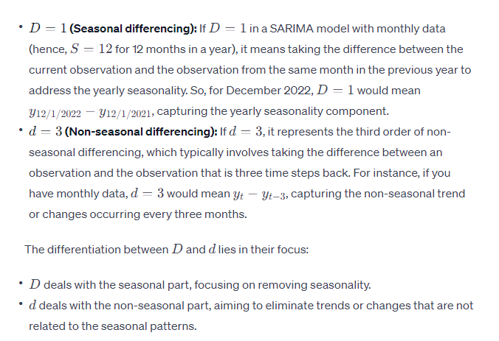

Q components – Moving Average order

q (Moving Average order) = 1: Refers to the number of lagged forecast errors in the prediction equation.
Q (Seasonal Moving Average order) = 1: Represents the seasonal moving average order.

The MA component of SARIMAX involves taking the error terms (the difference between the observed values and the predicted values from the model) and using them to predict future values in the series.
The order of the MA component (q) determines how many lagged error terms are used to predict the current value. It represents the number of terms in the model that contribute to the forecast at time t.

